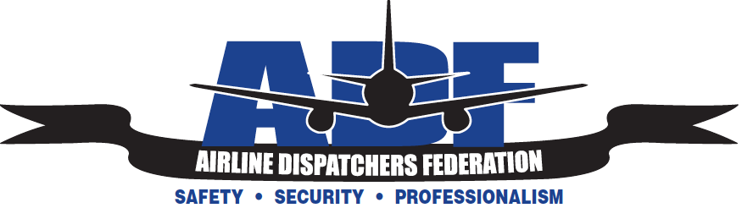

ADF Board Quarterly Summer Meeting Agenda

Date: July 26, 2014
Time: 13:00-17:00
Location: Seattle, Washington (SEA)

Hotel: Best Western Execute
Address: 20717 International Boulevard
Seattle Washington 98198s Vegas Boulevard S

Phone:(206) 878-3300
Rate: $113.00 PN (includes breakfast)
(email mberg@dispatcher.org with dates needed)

Hotel Transport: Airport Shuttle

1. Call to order.

2. Roll call.

3. Meeting Minutes from previous Board Meeting (DEN April 12, 2014)

4. Officers Reports
a. Opening Remarks/Nomination of ADF Board (EVP/Secretary per bylaws)
b. Presidents Reports (NACSC/ATC ARC/Video Project)
c. Executive Vice Presidents Report
d. 2014 Symposium
e. ADF’s Meeting Involvement (New/Old)
f. Treasurer, ADF Financials
g. Secretary Reports, DFW Meeting Minutes Approval
h. Directors Reports
i. VP Reports.
j. 2015 Business Meeting Dates, Locations
k. Other Business

5. Motion to adjourn

